**Questions**

1. Get all employees

SELECT * FROM employee;

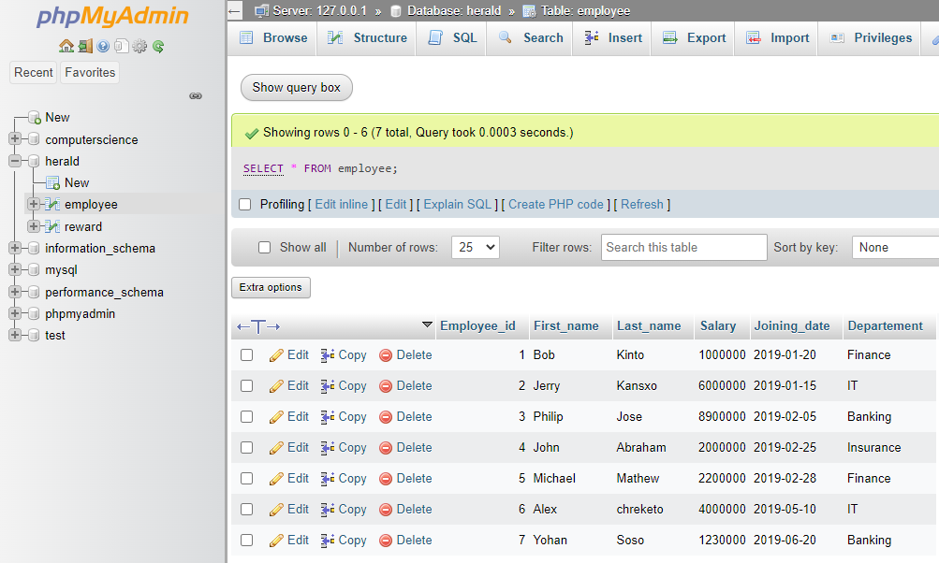

1. Display the first name and last name of all employees.

SELECT First_name, Last_name FROM employee;

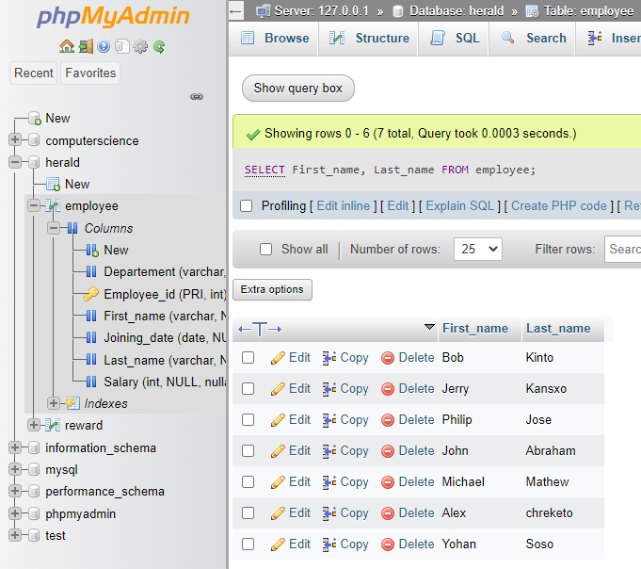

1. Display all the values of the “First_Name” column using the alias “Employee Name”

SELECT First_name AS "Employee Name" FROM employee;

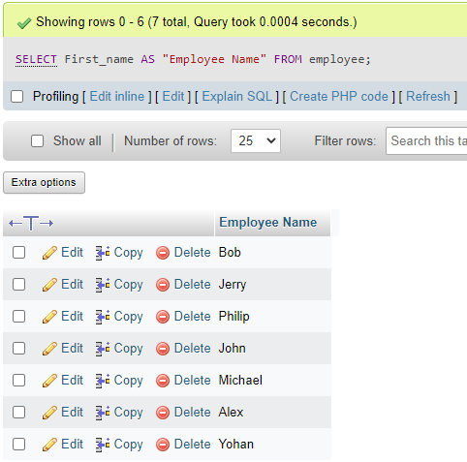

1. Get all “Last_Name” in lowercase.

SELECT LOWER(Last_name) FROM employee;

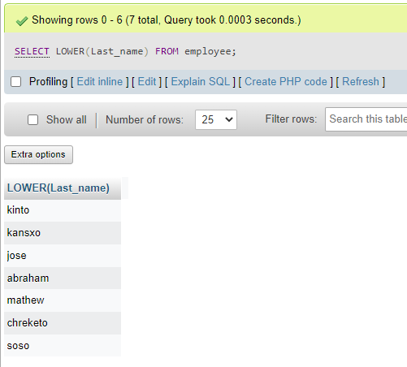

1. Get all “Last_Name” in uppercase.

SELECT UPPER(Last_name) FROM employee;

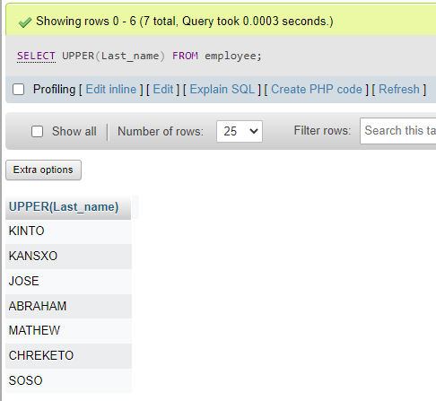

1. Get unique “DEPARTMENT”.

SELECT DISTINCT Departement FROM employee;

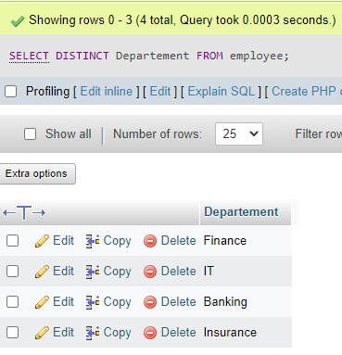

1. Get the first 4 characters of “FIRST_NAME” column.

SELECT SUBSTRING(First_name,1,4) FROM employee;

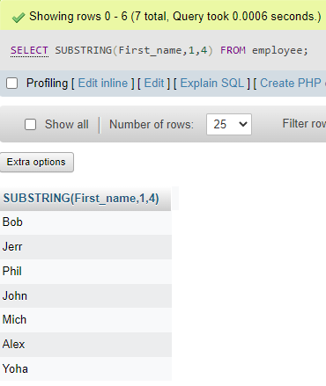

1. Get all values from the “FIRST_NAME” column after removing white space on the right.

SELECT RTRIM(First_name) FROM employee;

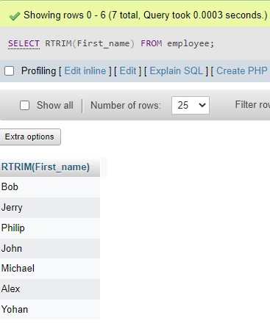

1. Get all values from the “FIRST_NAME” column after removing white space on the left.

SELECT LTRIM(First_name) FROM employee;

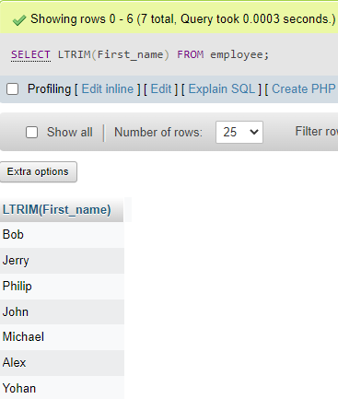

1. Write the syntax to create the “employee” table.

CREATE TABLE Employeee (Employee_id int AUTO_INCREMENT PRIMARY KEY, First_name VARCHAR(25), Last_name VARCHAR(25), Salary int, Joining_date Date, Departement VARCHAR(50));

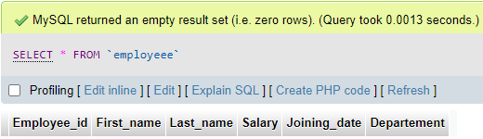

1. Get the length of the text in the “First_name” column.

SELECT LENGTH(First_name) FROM employee;

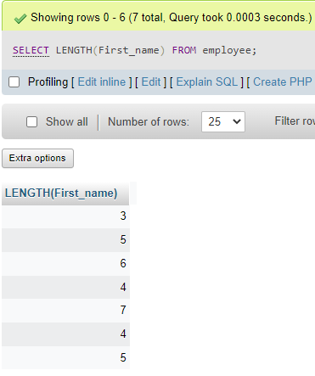

1. Get the employee’s first name after replacing ‘o’ with ‘#’.

SELECT REPLACE(First_name,'o','#') FROM employee;

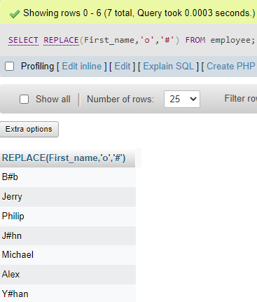

1. Get the employee’s last name and first name in a single column separated by a ‘_’.

SELECT CONCAT(First_name,'_',Last_name) FROM employee;

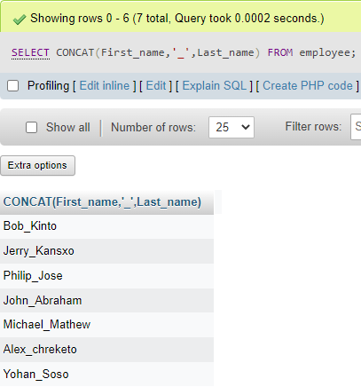

1. Get all employees in ascending order by first name.

SELECT * FROM employee ORDER BY First_name ASC;

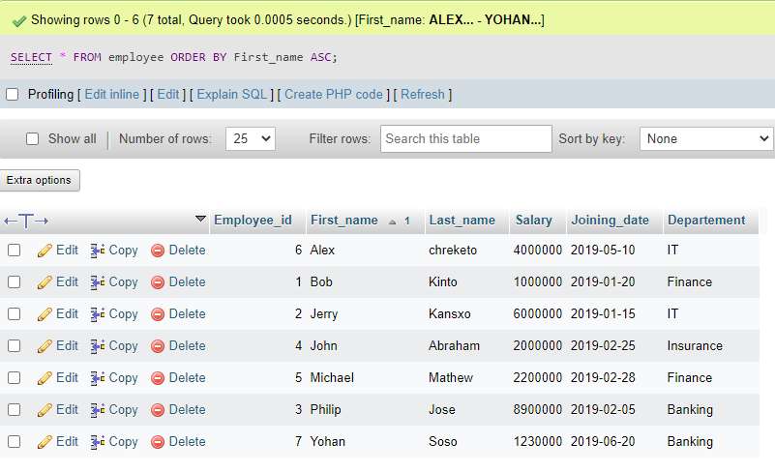

1. Get all employees in descending order by first name.

SELECT * FROM employee ORDER BY First_name DESC;

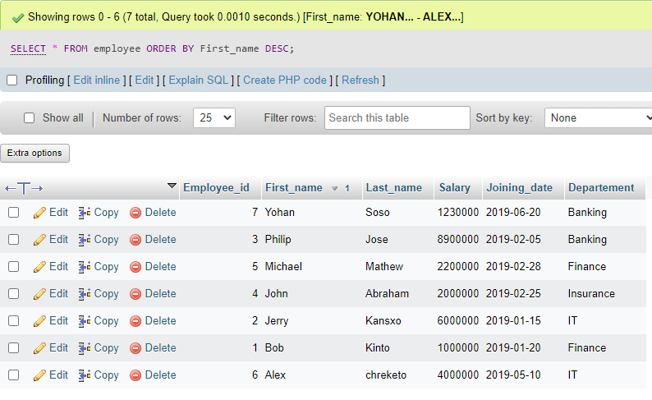

1. Get employees whose first name is “Bob”.

SELECT * FROM employee WHERE First_name='Bob';

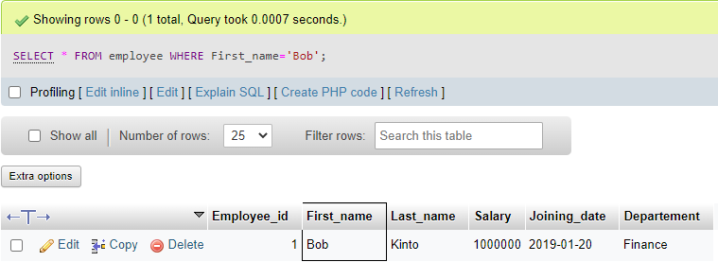

1. Get employees whose first name is “Bob” or “Alex”.

SELECT * FROM employee WHERE First_name IN ('Bob','Alex');

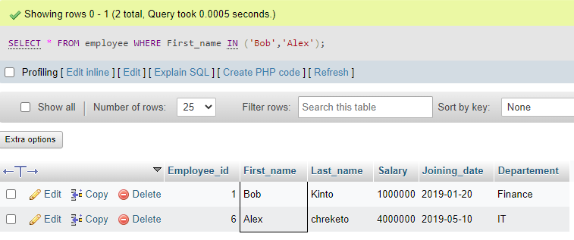

1. Get employees whose first name is neither “Bob” nor “Alex”.

SELECT * FROM employee WHERE First_name NOT IN ('Bob','Alex');

